Name______________________________

Teacher____________________________



10 Steps
to
A/A*Success

A PiXL 10-session Booster Resource for use by

Early Entry Linear GCSE students targeted at A/A*

Part 1
This booklet

This booster resource comprises 3 parts; 2 booklets (parts 1 and 2) and an interactive spreadsheet.

The first booklet comprises short tests (all out of 10 except Plotting & Interpreting Graphs which is out of 20). This could be used as a gauge of the position before booster work, and a guide to the emphasis needed in the booster work itself.

The second booklet contains a second set of questions on an identical list of topics, and could be used as a measure of progress made during the booster sessions.

We are aiming at creating students at A/A*, so the spreadsheet is set up to be Green for 9 or 10, Yellow for 7 or 8 and Red for 0-6

The topics chosen are generally self-explanatory, and should form the basis of a ten session booster course.

Contents

- Probability / Tree Diagrams / Histograms
- Understand conditional probability
- Know that the probability of A or B is P(A) + P(B)
- Know that the probability of A and B is P(A) × P(B)
- Be able to use tree diagrams "with replacement"
- Be able to use tree diagrams "without replacement"
- Be able to draw a histogram from a frequency table
- Be able to complete a frequency table from a histogram
- Cosine Rule / Area of a Triangle
- Know and be able to use the Sine Rule in calculations
- Know and be able to use the Cosine Rule in calculations
- Calculating the area of a triangle using ½ absinC
- Surface Area, Volume & Density / Area of Sector
- Be able to calculate the surface area of prisms, pyramids, cones & spheres
- Be able to calculate the volume of prisms, pyramids, cones & spheres
- Know that density is found by mass ÷ volume
- Use π in exact calculations, without a calculator
- Be able to calculate lengths of arcs of circles and the area of a sector of a circle
- Error Bounds / Recurring Decimals / Surds
- Calculate the upper and lower bounds of calculations.
- Be able to convert a recurring decimal to a fraction, eg show that 0.123123... = 41/333
- Rationalise the denominator of fractions containing surds, eg 1/√3 = √3/3, and eg write (√18 + 10) ÷ √2 in the form p + q√2
- Re-arranging complex formulae / Simultaneous Equations
- Change the subject of a formula where the subject occurs more than once, or where a power of the subject occurs
- Be able to solve simple examples of simultaneous equations involving one linear & one quadratic expression in one variable, e.g. y = 3x + 2 and y = x².
- Be able to interpret and solve simultaneous linear and quadratic equations graphically
- Be able to solve simultaneous equations involving one linear equation and the equation of a circle centred on the origin
- Circle Theorems / Complex Indices
- Know that the angle subtended by arc at centre is twice angle on circumference
- Know angles in a semi-circle are right angles
- Know angles in the same segment are equal
- Know opposite angles of a cyclic quadrilateral are = 180 degrees
- Know what a tangent is and that two tangents from the same point are equal
- Know that a radius that meets the circumference at the same point as a tangent makes a right-angle with the tangent
- Understand and be able to use index rules for multiplication and division, positive, negative and fractional indices to simplify expressions involving powers, eg (2³ × 2⁵) ÷ 2⁴, 4⁰, 8^{–2/3}
- Algebraic Fractions / Quadratic Equations
- Solve quadratic equations by factorising where a not equal to 1
- Understand and be able to use completing the square as a method of solving quadratic equations
- Use completing the square to write down the maximum/minimum of the function
- Understand and be able to use the quadratic formula as a method of solving quadratic equations
- Cancel common factors in algebraic fractions
- Be able to solve linear equations with fractions e.g. 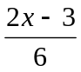 + 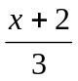 = 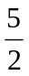
- Congruence / Vectors
- Prove formally that two triangles are congruent using SAS, SSS, ASA, RHS arguments
- Use scale factors to find the length of a missing side using similar shapes
- Know and use the relationship between linear, area and volume scale factors of similar shapes
- Understand the definition of a vector as being a displacement in the plane
- Be able to calculate the magnitude of a vector
- Be able to calculate and draw the sum/difference of two or more vectors
- Understand the relationship between 2a and -a to a
- Solve geometrical problems in 2-D, eg show that joining the midpoints of the sides of any quadrilateral forms a parallelogram
- Plotting & Interpreting Graphs / Transformation of Functions
- Can plot, recognise and sketch cubic and reciprocal graphs
- Can plot, sketch and be able to interpret y = pq^{x}
- Given two points on the curve y = pq^{x} , can calculate the values of p and q
- Given the graph of f(x) and the value a, can sketch the graph of y = f(x) + a and y = f(x-a)
- Given the graph of f(x) and the value a, can sketch the graph of y = f(ax) and y = a.f(x)
- Can sketch the graph of combinations of transformations, e.g. y = a.f(bx)
- Can plot, recognise and sketch sin, cos, tan graphs
- Apply the above transformations to sin and cos curves
- Algebraic Proof / AO2-3 Questions
Session 1 Conditional Probability / Tree Diagrams / Histograms

Conditional Probability 1

Content

- Understand conditional probability
- Know that the probability of A or B is P(A) + P(B)
- Know that the probability of A and B is P(A) × P(B)

Question 1

Jenni has a box of chocolates.
The box contains 6 plain, 4 milk and 5 white chocolates.
Jenni takes two chocolates at random from the box.

Work out the probability that at least one of these chocolates will be a milk chocolate.

………………………………
(Total 4 marks)

Question 2
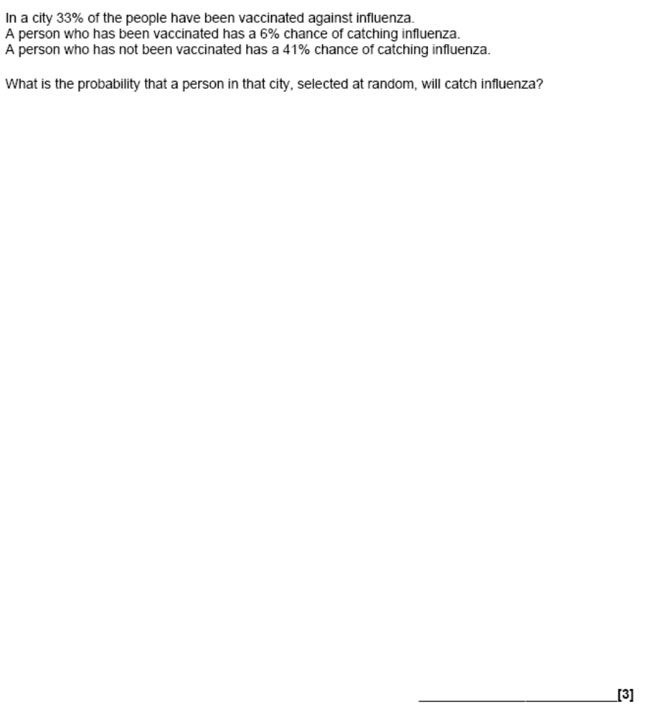

Question 3

A bag contains 6 black beads, 10 red beads and 4 green beads.
Helen takes a bead at random from the bag, records its colour and replaces it.
She does this two more times.
Work out the probability that, of the three beads Helen takes, exactly two will be the same colour.

.................................
(Total 3 marks)

Total / 10

Tree Diagrams 1

Content

- Be able to use tree diagrams "with replacement"
- Be able to use tree diagrams "without replacement"

Question 1
Julie and Pat are going to the cinema.
The probability that Julie will arrive late is 0.2
The probability that Pat will arrive late is 0.6
The two events are independent.
(a) Complete the diagram.
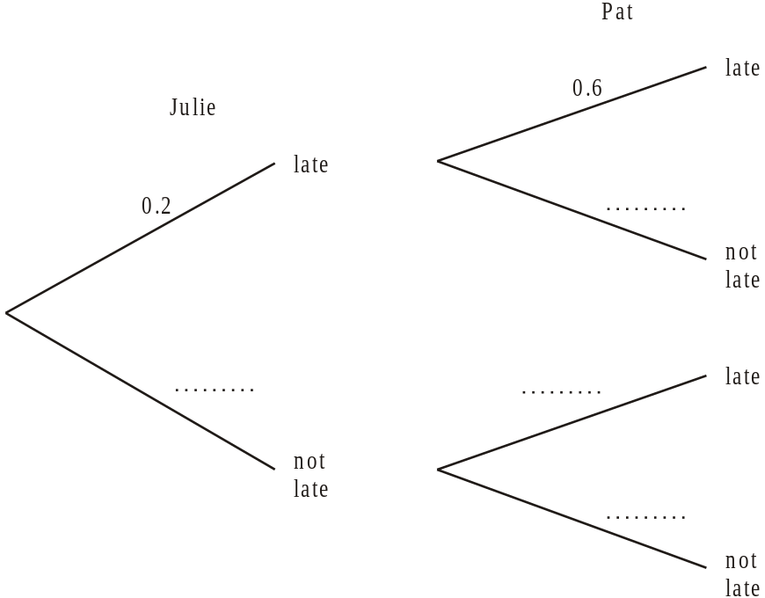
(2)

(b) Work out the probability that Julie and Pat will both arrive late.

……………………………
(3)
(Total 5 marks)

Question 2

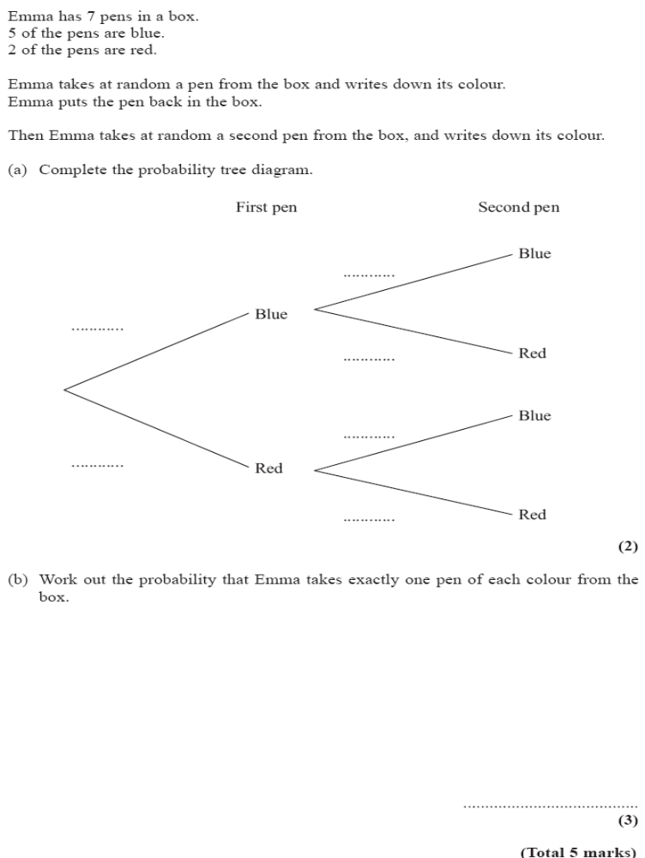
Total Mark / 10
Histograms 1

Content

- Be able to draw a histogram from a frequency table
- Be able to complete a frequency table from a histogram

Question 1
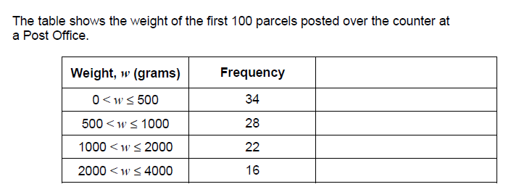
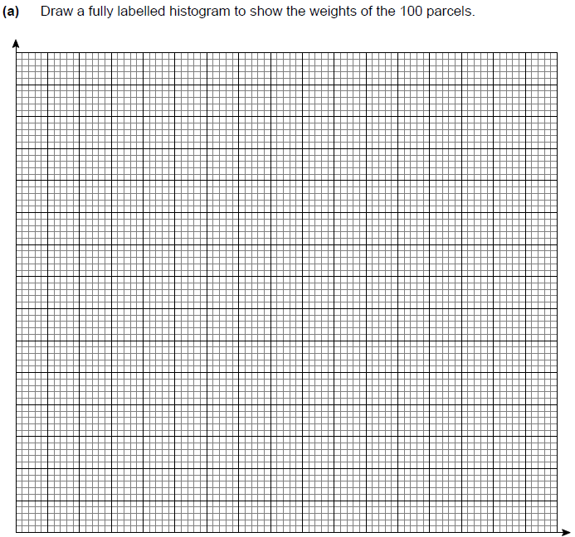
(4 marks)
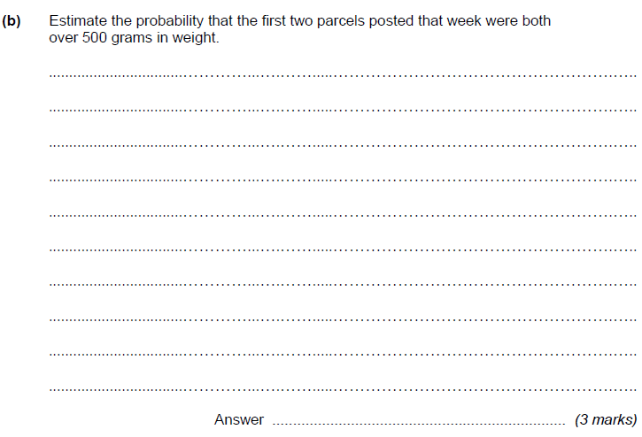

Question 2

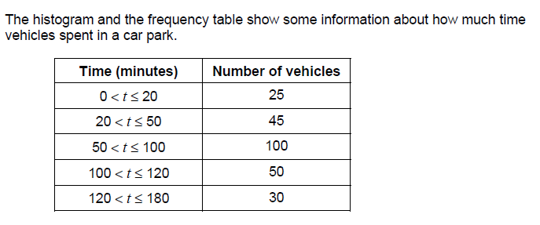

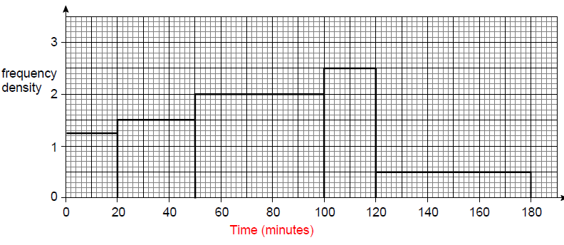

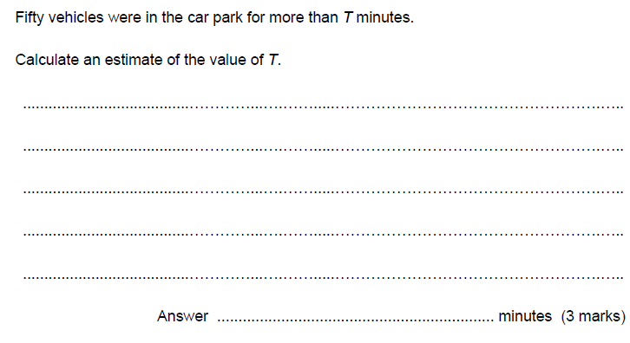

Total / 10
Session 2 Sine Rule / Cosine Rule / Area of a Triangle

Cosine and Sine Rule 1

Content

- Know and be able to use the Sine Rule in calculations
- Know and be able to use the Cosine Rule in calculations

This information is provided on the formulae sheet.

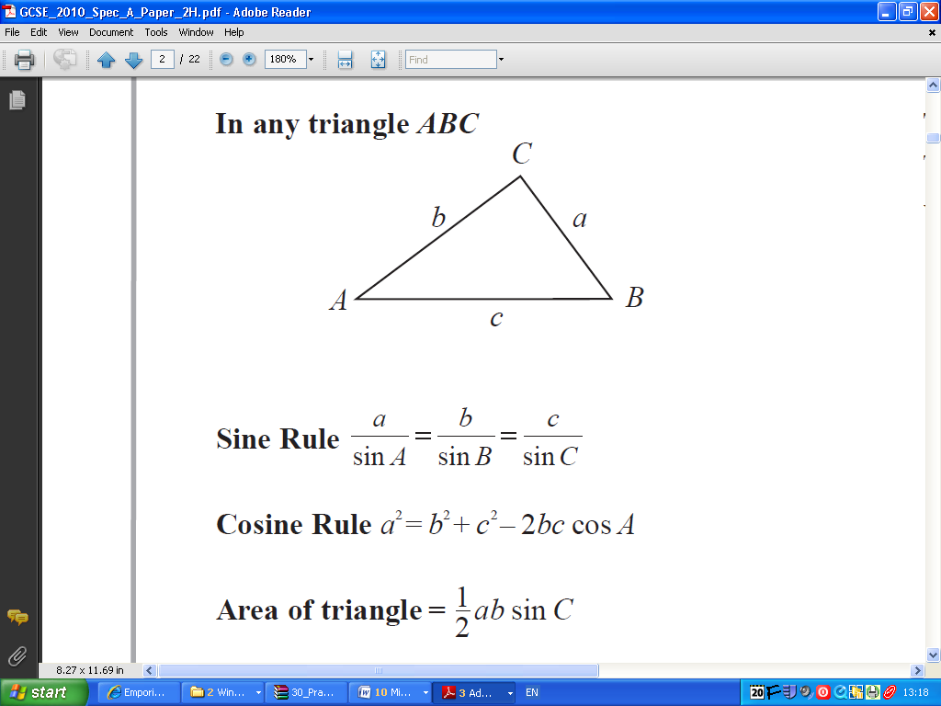

Question 1

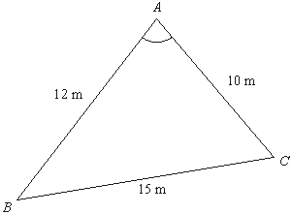
Diagram NOT accurately drawn
ABC is a triangle.
AB = 12 m.
AC = 10 m.
BC = 15 m.

Calculate the size of angle BAC.
Give your answer correct to one decimal place.

................................°
(3 marks)

Question 2

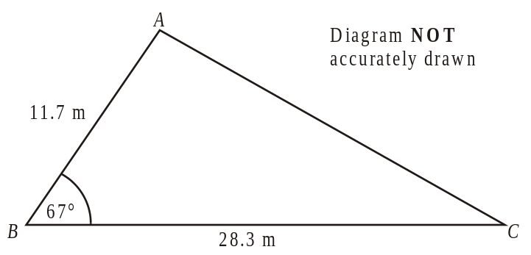
AB = 11.7 m.
BC = 28.3 m.
Angle ABC = 67°.
Calculate the length of AC.
Give your answer correct to 3 significant figures.

…………………………. m
(3 marks)

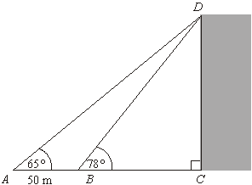
Question 3

Steve is working out the height of a tall vertical building CD.
The building is standing on horizontal ground.
Steve measures the angle of elevation of the top, D, of the building from two different points A and B.
The angle of elevation of D from A is 65°.
The angle of elevation of D from B is 78°.
AB = 50 m.
ABC is a straight line.
Calculate the height; give your answer correct to 3 significant figures.

..................................... m
(6 marks)
Total / 10

Area of Triangles 1

Content

- Calculating the area of a triangle using ½ absinC

This information is provided on the formulae sheet.

Question 1
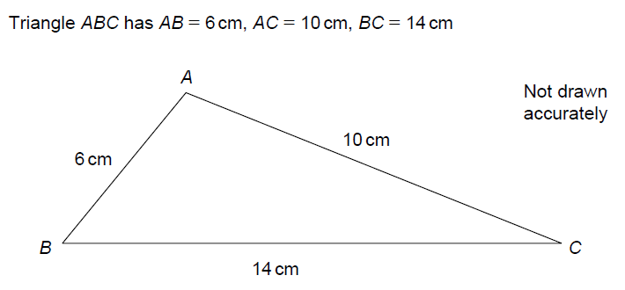
Calculate the area of this triangle

(5 marks)

Question 2

Diagram NOT
accurately drawn
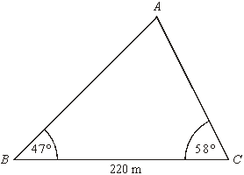
Angle ABC = 47°
Angle ACB = 58°
BC = 220 m

Calculate the area of triangle ABC.
Give your answer correct to 3 significant figures.

.....................................
(Total 5 marks)

Total / 10

Session 3 Surface Area, Volume & Density / Area of Sector

Problems involving surface area and volume 1

Content:
- Be able to calculate the surface area of prisms, pyramids, cones & spheres
- Be able to calculate the volume of prisms, pyramids, cones & spheres
- Know that density is found by mass ÷ volume
- Use π in exact calculations,
- Be able to calculate lengths of arcs of circles and the area of a sector of a circle

Question 1

The mass of 5 m³ of copper is 44 800 kg.

(a) Work out the density of copper.

…………………………… kg/m³
(2)

The density of zinc is 7130 kg/m³.

(b) Work out the mass of 5 m³ of zinc.

………………………… kg
(2)
(Total 4 marks)

Question 2

PQ is an arc of the circle.
Angle POQ = 120°

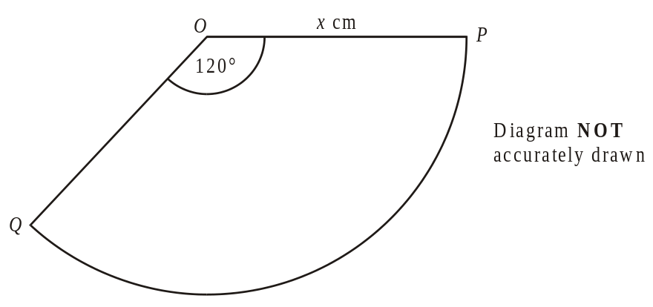

(a) Write down an expression in terms of π and x for

(i) the area of this sector,

................................

(ii) the arc length of this sector.

................................

(2)

Question 3

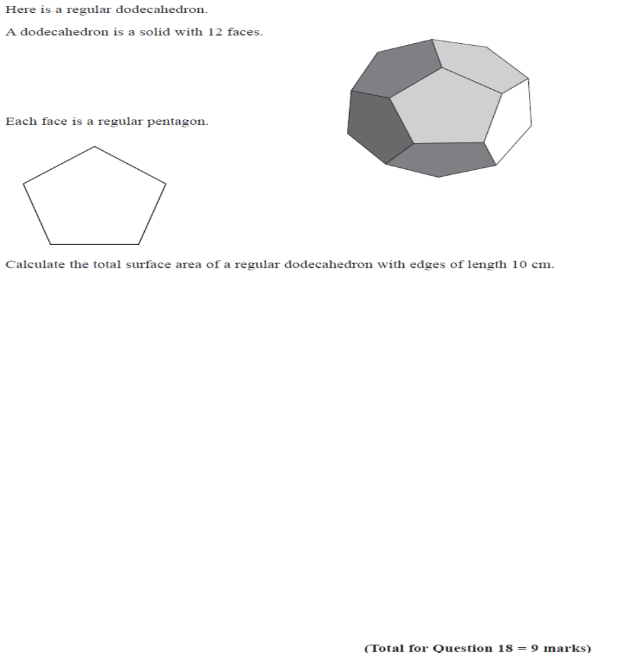

(Total 4 marks)
Total / 10

Session 4 Error Bounds / Recurring Decimals / Surds

Error Bounds 1

Content:
- Calculate the upper and lower bounds of calculations.

Question 1

The length of a rectangle is 30 cm, correct to 2 significant figures

The width of a rectangle is 18 cm, correct to 2 significant figures

- Write down the upper bound of the width
……………………………..

(1 mark)

- Calculate the upper bound for the area of the rectangle

…………………………….

(2 marks)

Question 2

The length of the base of a triangle is 12cm, correct to the nearest cm.
The area of the triangle is 60cm², correct to the nearest 10cm².

Calculate the upper and lower bounds of the height of the triangle

Upper Bound ___________________cm

Lower Bound ___________________cm

(5 marks)

Question 3

Katy drove for 238 miles, correct to the nearest mile.
She used 27.3 litres of petrol, to the nearest tenth of a litre.

Petrol consumption = 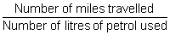

Work out the upper bound for the petrol consumption for Katy’s journey.
Give your answer correct to 2 decimal places.

...................................... miles per litre
(3 marks)

Total / 10

Surds 1

Content:
- Rationalise the denominator of fractions containing surds, eg 1/√3 = √3/3, and eg write (√18 + 10) ÷ √2 in the form p + q√2

Question 1
Expand
Give your answer in the form a + b where a and b are integers.

....................................
(2 marks)

Question 2

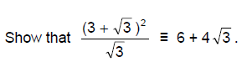

(3 marks)

Question 3

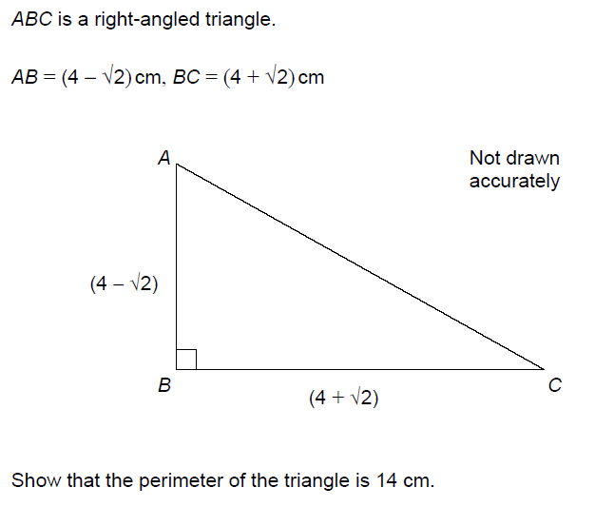

(5 marks)
Total / 10
Recurring decimals & fractions 1

Content:
- Be able to convert a recurring decimal to a fraction, eg show that 0.123123... = 41/333

Question 1
(a) Express 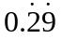 as a fraction in its simplest form.

……………………………
(2)
x is an integer such that 1 ≤ x ≤ 9
(b) Prove that 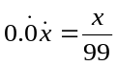

(2)
(Total 4 marks)

Question 2
Prove that the recurring decimal 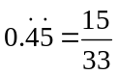

(Total 3 marks)

Question 3

Express the recurring decimal 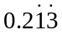 as a fraction.

....................
(Total 3 marks)

Total / 10

Session 5 Re-arranging Formulae / Simultaneous Equation

Simultaneous Equations 1

Content
- Be able to solve simple examples of simultaneous equations involving one linear & one quadratic expression in one variable, e.g. y = 3x + 2 and y = x².
- Be able to interpret and solve simultaneous linear and quadratic equations graphically
- Be able to solve simultaneous equations involving one linear equation and the equation of a circle centred on the origin

Question 1

Solve the simultaneous equations

5x - 2y = 13

7x + 4y = 8

x =
y =

(4 marks)

Question 2

Solve the simultaneous equations
x² + y² = 5
y = 3x + 1

x = .................... y = .....................
or x = .................... y = .....................

(6 marks)
Total / 10

Rearranging Complex Formulae 1

Content
- Change the subject of a formula where the subject occurs more than once, or where a power of the subject occurs

Question 1

Make m the subject of the formula p = h + 6m

(2 marks)

Question 2

Rearrange 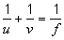

to make u the subject of the formula.
Give your answer in its simplest form.

.....................................
(2 marks)

Question 3

Make s the subject of the formula v² = u² + 2as

s = .................................
(2 marks)

Question 4

Make b the subject of the formula 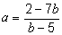

.......................................................
(4 marks)
Total / 10

Session 6 Circle Theorems / Complex Indices

Circle Theorems 1

Content
- Know that the angle subtended by arc at centre is twice angle on circumference
- Know angles in a semi-circle are right angles
- Know angles in the same segment are equal
- Know opposite angles of a cyclic quadrilateral are = 180 degrees
- Know what a tangent is and that two tangents from the same point are equal
- Know that a radius that meets the circumference at the same point as a tangent makes a right-angle with the tangent

Question 1
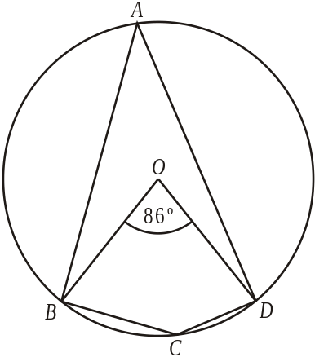 Diagram NOT accurately drawn
A, B, C and D are points on the circle, centre O. Angle BOD = 86º
(a) (i) Work out the size of angle BAD.
...........................º
(ii) Give a reason for your answer.
...........................................................................................................................
............................................................................................................................
(2)
(b) (i) Work out the size of angle BCD.
...........................º
(ii) Give a reason for your answer.
...........................................................................................................................
............................................................................................................................
(2)
(Total 4 marks)

Question 2

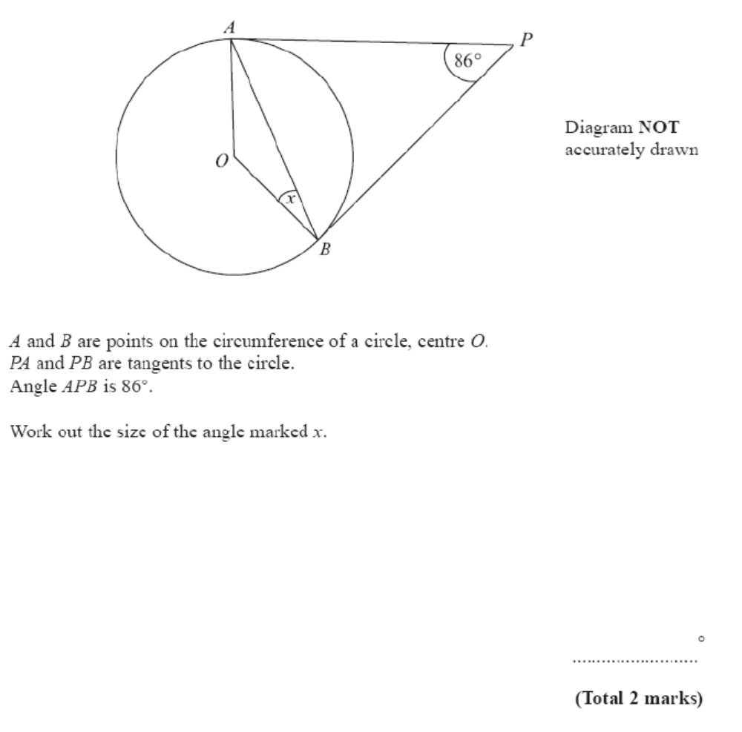

Question 3

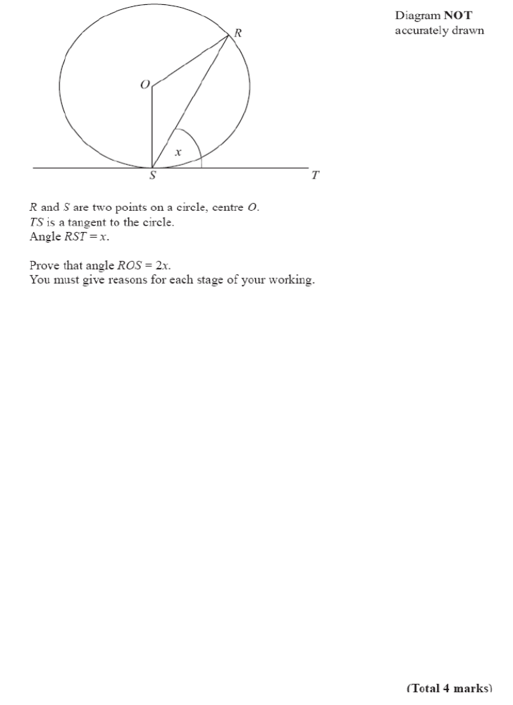
Total Mark / 10
Complex Indices 1

Content
- Understand and be able to use index rules for multiplication and division, positive, negative and fractional indices to simplify expressions involving powers, eg (2³ × 2⁵) ÷ 2⁴, 4⁰, 8^{–2/3}

Question 1

Work out the value of

(a) (2²)³

.................................
(1)

(b) (√3)²

.................................
(1)
(c) 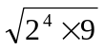

.................................
(2)
(d) 4^{–2}

.................................
(1)
(Total 5 marks)
Question 2
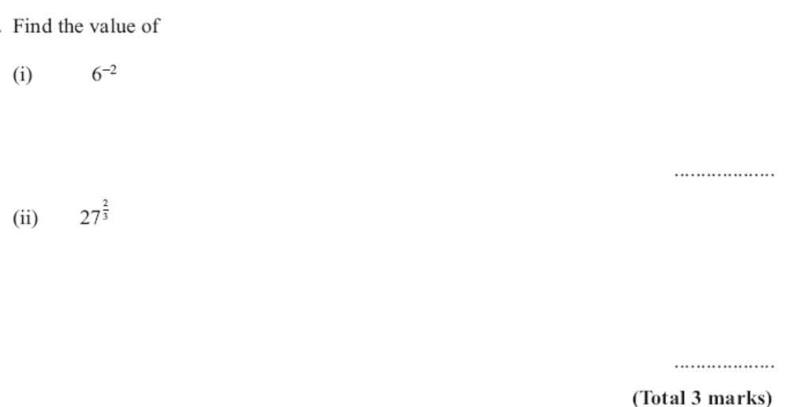
Question 3
(a) Write down the value of 8

.....................................
(1)
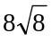 be written in the form 8k
(b) Find the value of k.

k = .....................................
(1)
.
(Total 2 marks)

Total Mark / 10

Session 7 Algebraic Fractions / Quadratic Equations

Algebraic fractions 1

Content
- Cancel common factors in algebraic fractions
- Be able to solve linear equations with fractions e.g. + =

Question 1

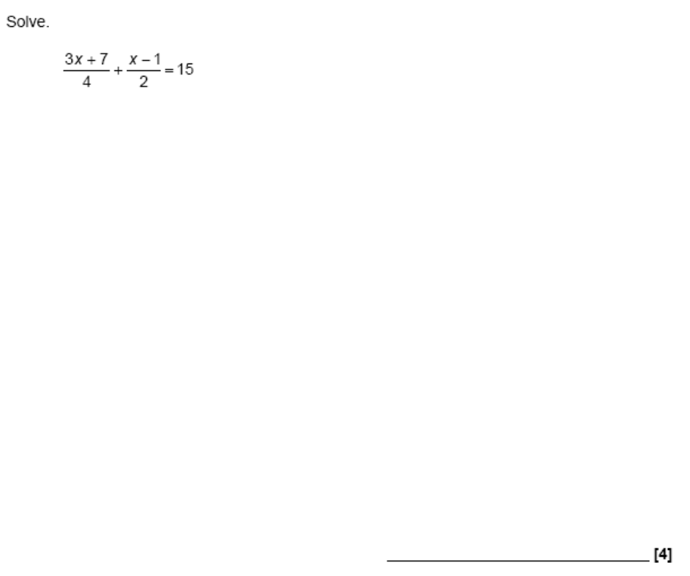

Question 2
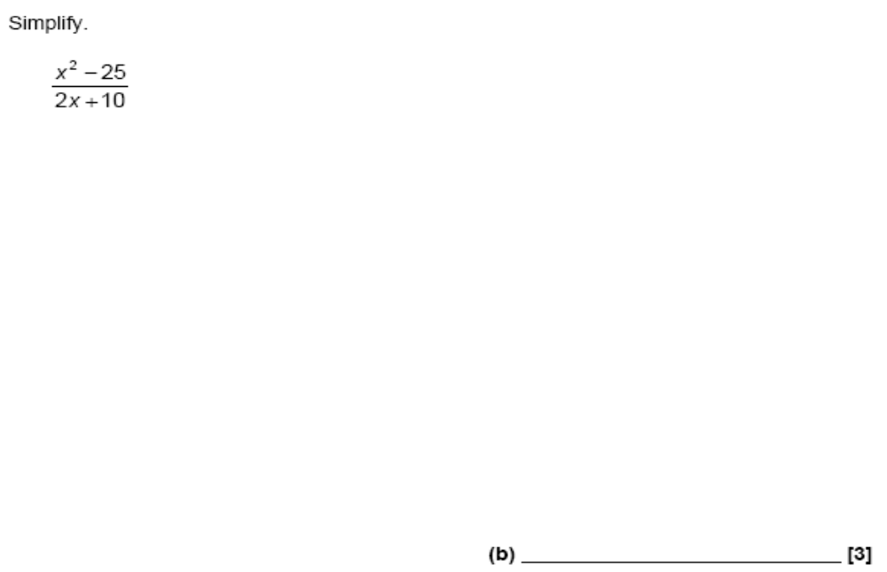

Question 3

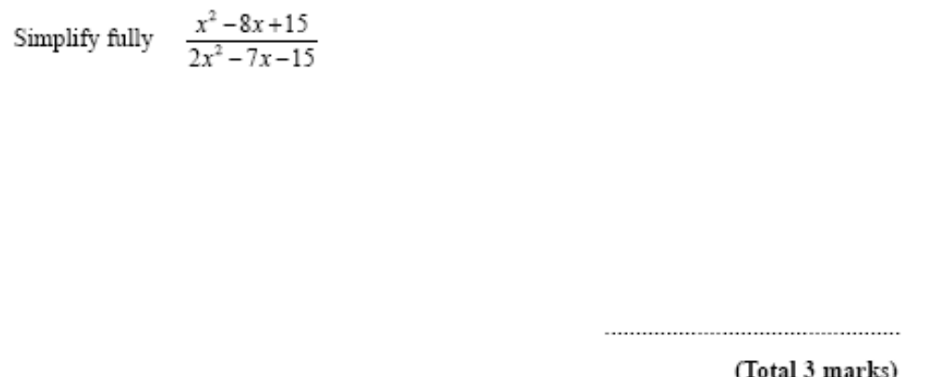

Total / 10

Quadratic equations 1

Content
- Solve quadratic equations by factorising where a not equal to 1
- Understand and be able to use completing the square as a method of solving quadratic equations
- Use completing the square to write down the maximum/minimum of the function
- Understand and be able to use the quadratic formula as a method of solving quadratic equations

Question 1

Solve x² – 3x – 18 = 0

……………………………
(3)
(Total 3 marks)

Question 2
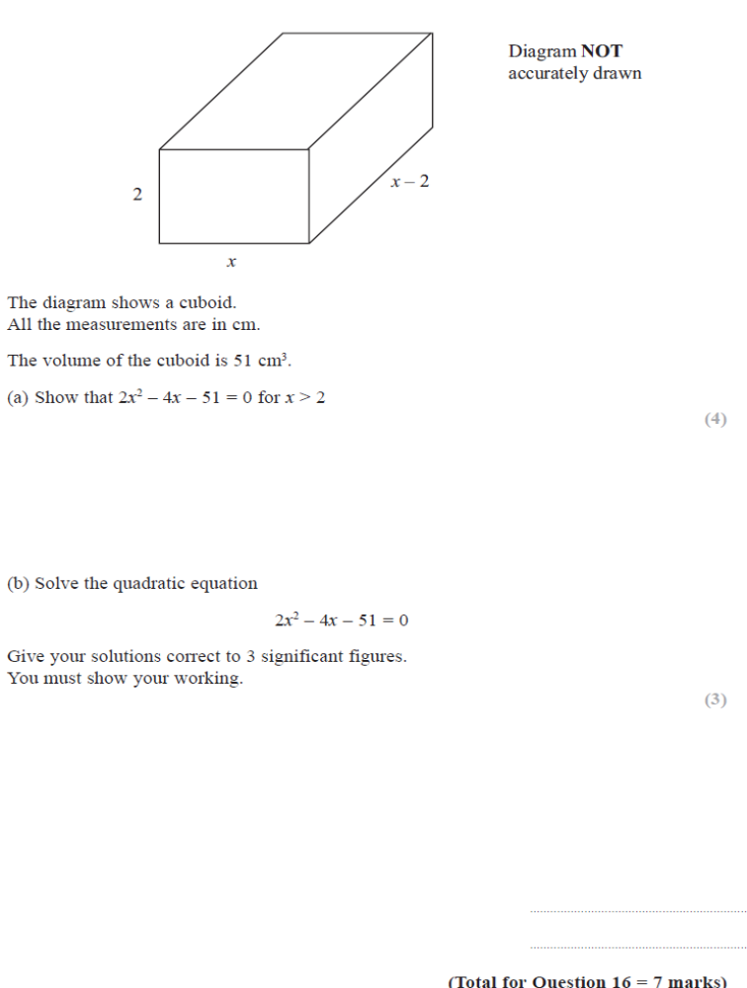
Total / 10
Session 8 Congruence & Similarity / Vectors

Vectors 1

Content
- Understand the definition of a vector as being a displacement in the plane
- Be able to calculate the magnitude of a vector
- Be able to calculate and draw the sum/difference of two or more vectors
- Understand the relationship between 2a and -a to a
- Solve geometrical problems in 2-D, eg show that joining the midpoints of the sides of any quadrilateral forms a parallelogram

Question 1
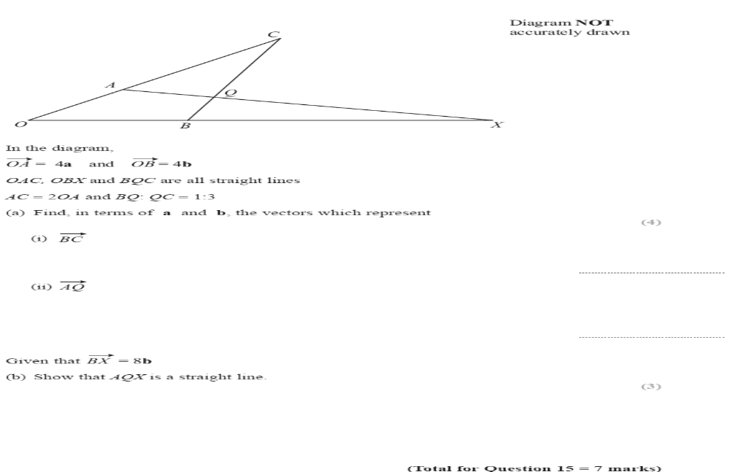

(total 3 marks)

Question 2
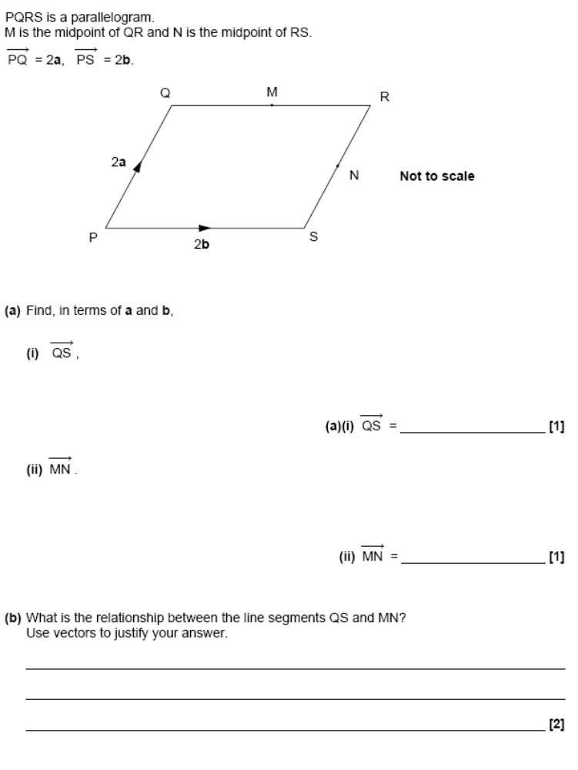

Question 3

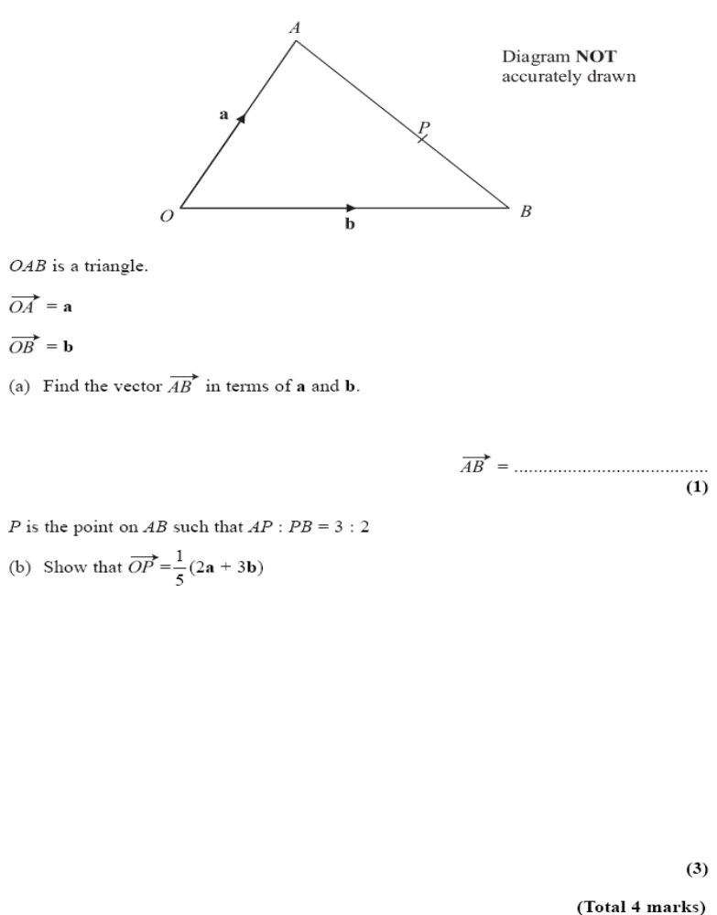
(2)
Total / 10

Congruence & Similarity 1

Content
- Prove formally that two triangles are congruent using SAS, SSS, ASA, RHS arguments
- Use scale factors to find the length of a missing side using similar shapes
- Know and use the relationship between linear, area and volume scale factors of similar shapes

Question 1

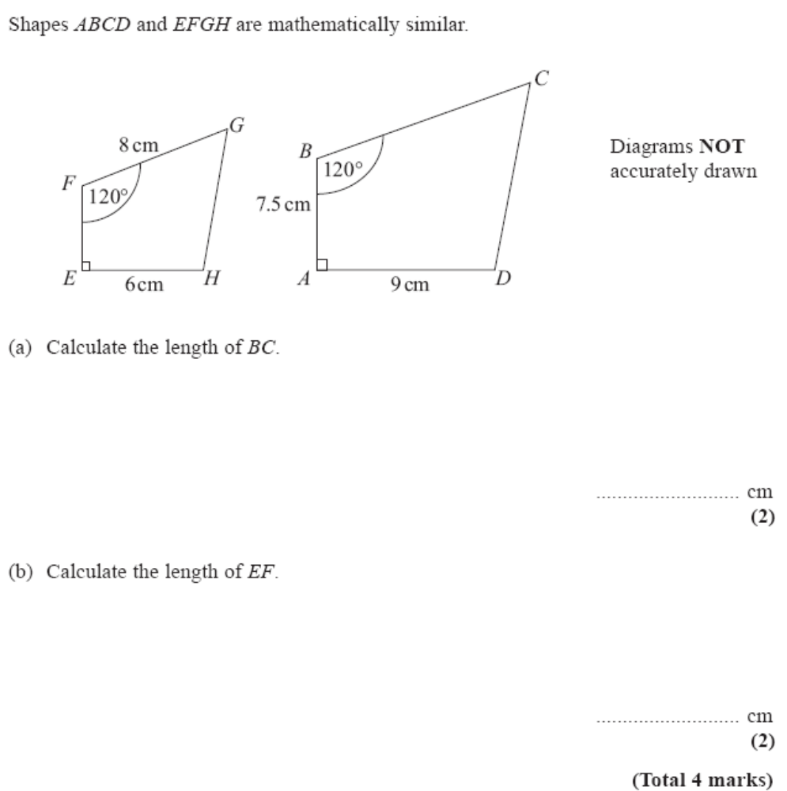

Question 2

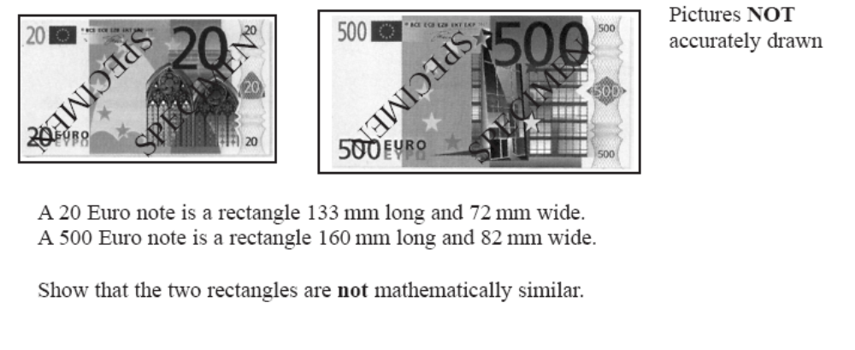

(Total 3 marks)

Question 3
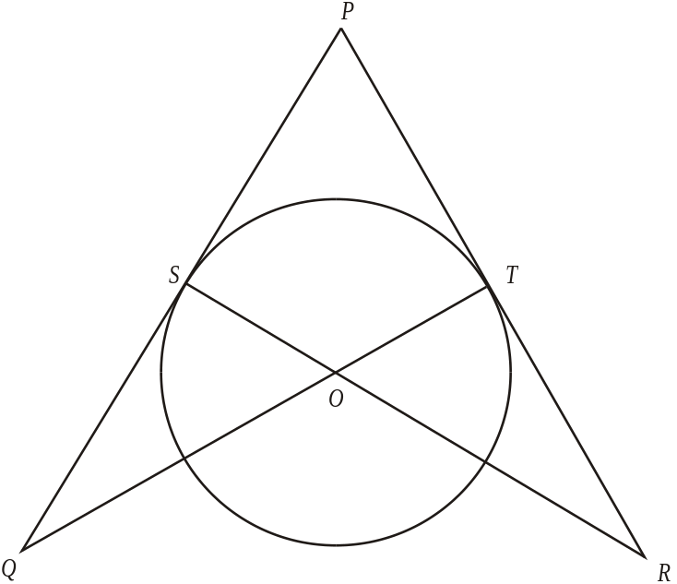

Diagram NOT accurately drawn

S and T are points on a circle, centre O.
PSQ and PTR are tangents to the circle.
SOR and TOQ are straight lines.

Prove that triangle PQT and triangle PRS are congruent.

(Total 3 marks)
Total / 10
Session 9 Plotting & Interpreting Graphs / Transformation of
Functions

Transformation of functions 1

Content
- Given the graph of f(x) and the value a, can sketch the graph of y = f(x) + a and y = f(x-a)
- Given the graph of f(x) and the value a, can sketch the graph of y = f(ax) and y = a.f(x)
- Can sketch the graph of combinations of transformations, e.g. y = a.f(bx)
- Apply the above transformations to sin and cos curves

Question 1

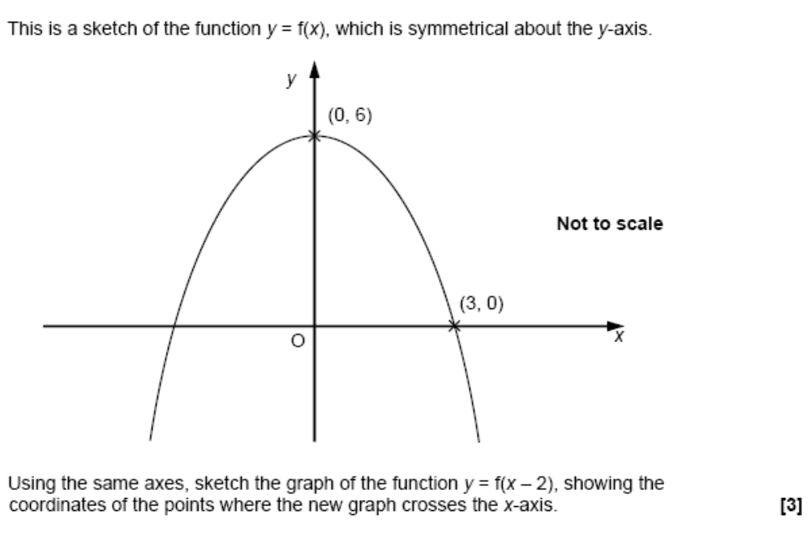

Question 2

This is a sketch of the curve with equation y = f(x).
It passes through the origin O.

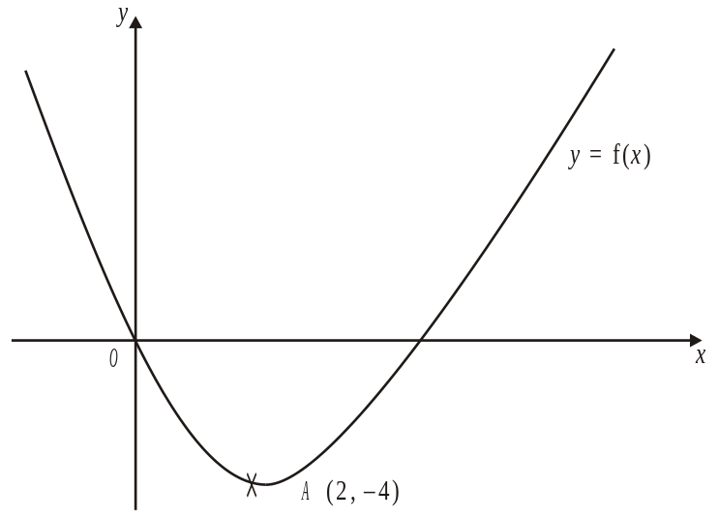

The only vertex of the curve is at A (2, –4)

Write down the coordinates of the vertex of the curve with equation

(i) y = f(x – 3),
(...... , ......)
(ii) y = f(x) – 5,
(...... , ......)
(iii) y = –f(x),
(...... , ......)
(iv) y = f(2x).
(...... , ......)

(Total 4 marks)

Question 3
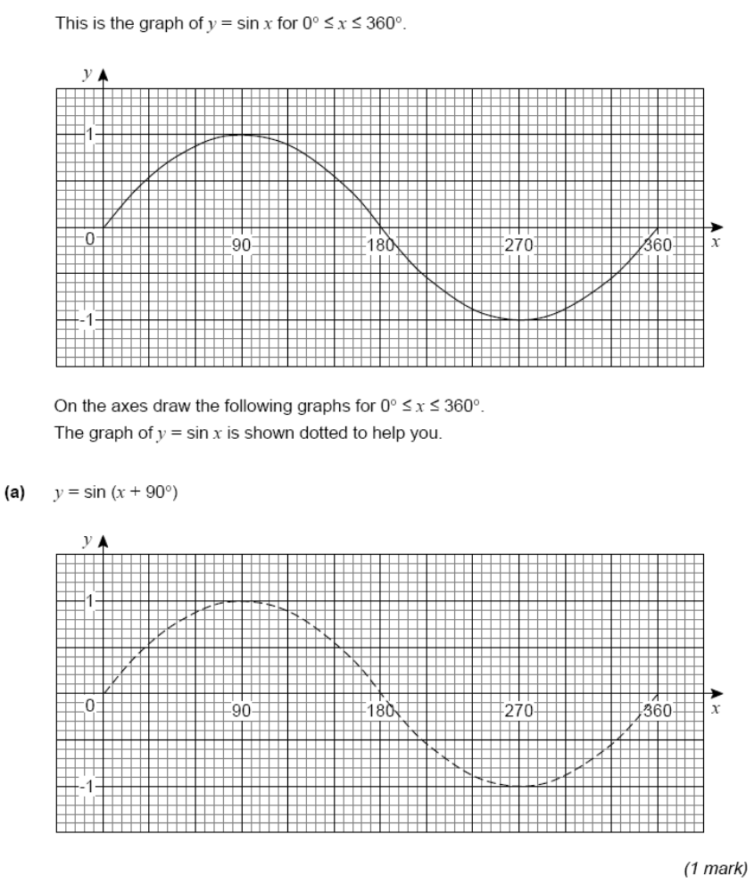
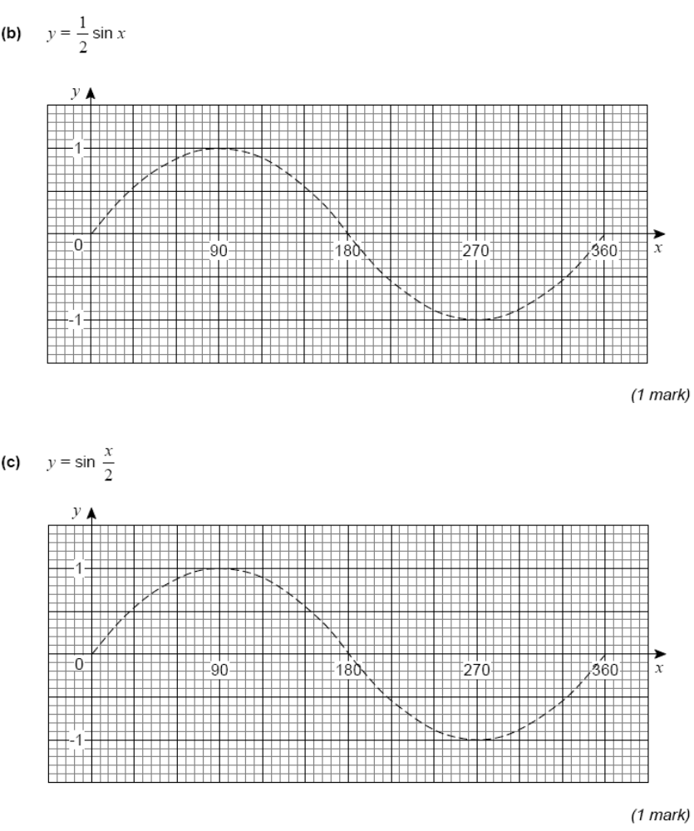

Total / 10

Plotting & interpreting graphs 1

Content
- Can plot, recognise and sketch cubic and reciprocal graphs
- Can plot, sketch and be able to interpret y = pq^{x}
- Given two points on the curve y = pq^{x} , can calculate the values of p and q
- Can plot, recognise and sketch sin, cos, tan graphs

Question 1
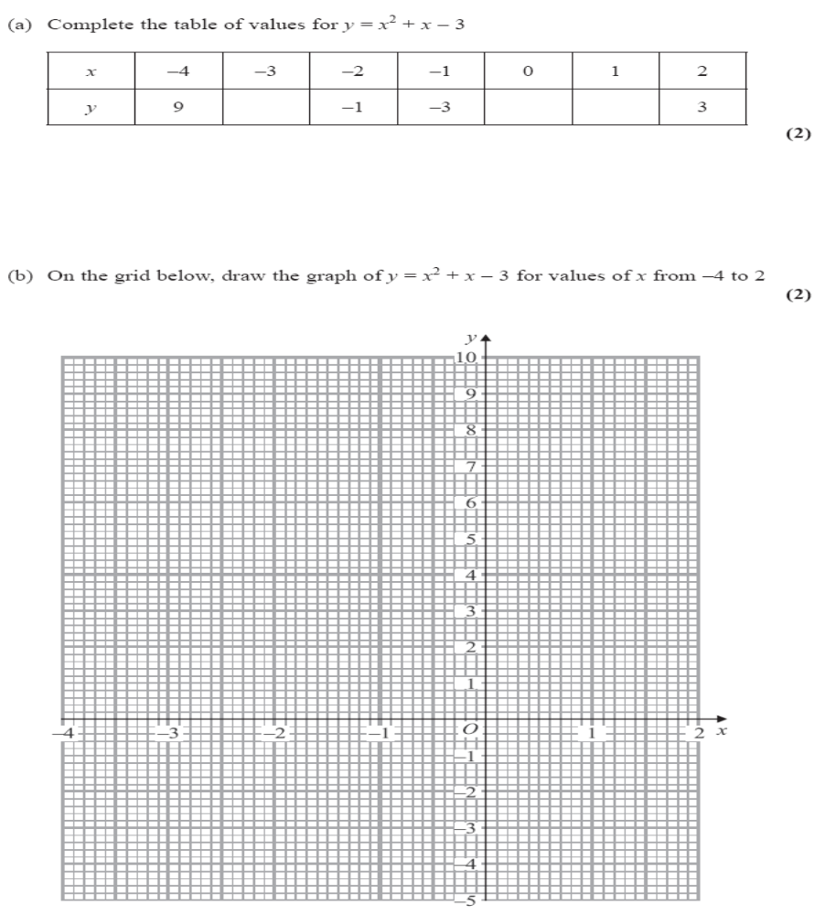
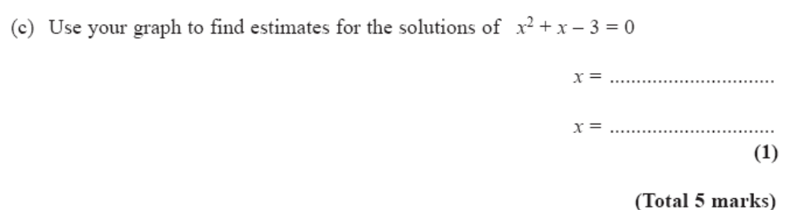

Question 2
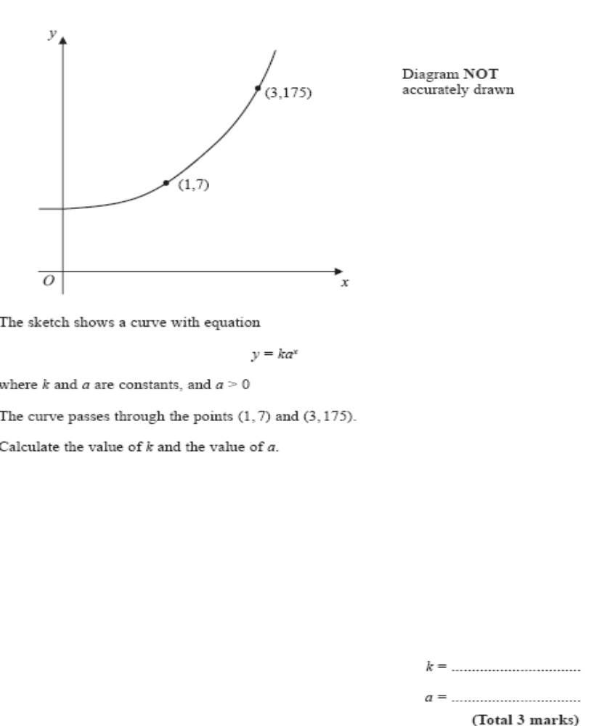
Total 5 marks

Question 3
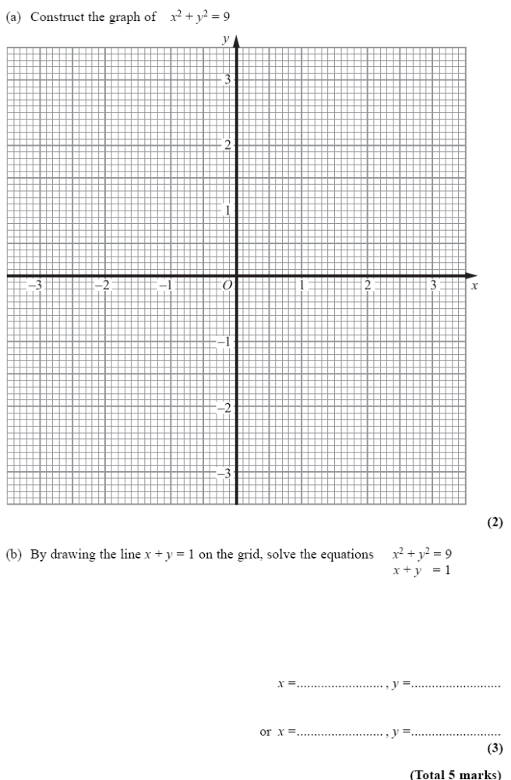

Question 4

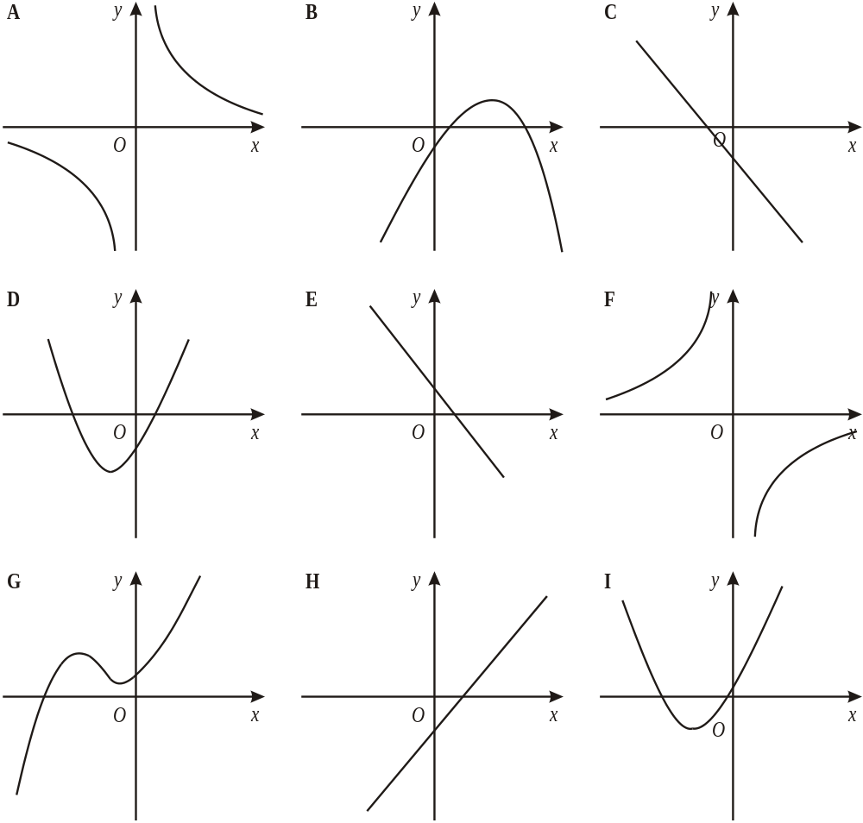

Write down the letter of the graph which could have the equation

(i) y = 3x – 2
……………

(ii) y = 2x² + 5x – 3
……………
(iii) y = 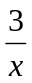
……………
(Total 5 marks)
Total / 20
Session 10 Algebraic Proof / AO2-3

Algebraic proof 1

Question 1

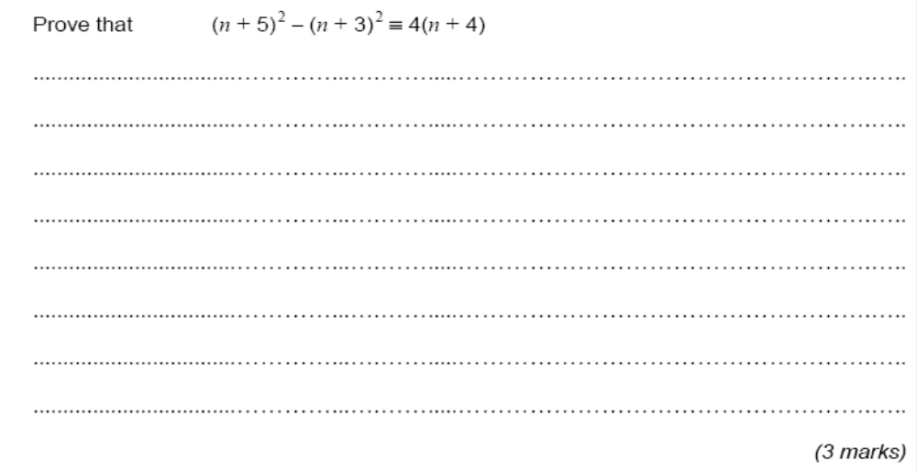

(Total 4 marks)

Question 2

The nth even number is 2n.
The next even number after 2n is 2n + 2
(a) Explain why.
.....................................................................................................................................
.....................................................................................................................................
(1)

(b) Write down an expression, in terms of n, for the next even number after 2n + 2

.....................................
(1)

(c) Show algebraically that the sum of any 3 consecutive even numbers is always a multiple of 6

(4)

(Total 6 marks)

Total / 10
AO2/3 Questions 1

Question 1

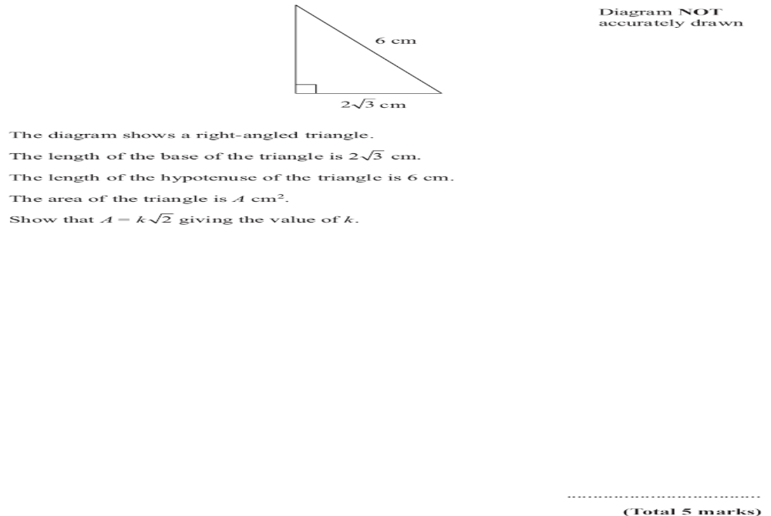

Question 2

Samantha wants to buy a new pair of trainers.

There are 3 shops that sell the trainers she wants.

Sports ‘4’ All |  | Edexcel Sports |  | Keef’s Sports
Trainers |  | Trainers |  | Trainers
£5 |  | off |  | £50
plus |  | usual price of |  | plus
12 payments of £4.50 |  | £70 |  | VAT at 20%

From which shop should Samantha buy her trainers to get the best deal?
You must show all of your working.

(Total 5 marks)

Total Mark / 10

